**Project Planning Phase**

**Project Planning Template (Product Backlog, Sprint Planning, Stories, Story points)**

|  |  |
| --- | --- |
| Date | 22 October 2022 |
| Team ID | PNT2022TMID53250 |
| Project Members | Bharanidharan S, Elakkiya S, Pooja T S, Reethika S |
| Project Name | Visualizing and Predicting Heart Diseases with an Interactive Dash Board |
| Project mentors | Industry mentor - Mahidhar, Saumya  Faculty mentor – Dr. Arulkumar Venkatachalam |

**Product Backlog, Sprint Schedule, and Estimation (4 Marks)**

|  |  |  |  |  |  |  |
| --- | --- | --- | --- | --- | --- | --- |
| **Sprint** | **Functional**  **Requirement (Epic)** | **User Story**  **Number** | **User Story / Task** | **Story Points** | **Priority** | **Team Members** |
| Sprint-1 | Registration | USN-1 | As a user, I can register for the application by entering my email, password, and confirming my password. | 5 | High | Reethika S , Elakkiya S |
| Sprint-1 |  | USN-2 | As a user, I will receive confirmation email once I have registered for the application | 3 | High | Pooja T S , Bharanidharan S |
| Sprint-1 |  | USN-3 | As a user, I can register for the application through Facebook | 2 | Low | Reethika S |
| Sprint-1 |  | USN-4 | As a user, I can register for the application through Google | 2 | Medium | Bharanidharan S |
| Sprint-1 | Login | USN-5 | As a user, I can log into the application by entering email & password | 3 | High | Pooja T S , Elakkiya S |
| Sprint-2 | Dashboard | USN-6 | As a User, I can view my complete medical analysis & accuracy and prediction of heart disease in a dashboard | 5 | High | Reethika S , Bharanidharan S , Pooja T S , Elakkiya S |

|  |  |  |  |  |  |  |
| --- | --- | --- | --- | --- | --- | --- |
| Sprint-2 | User entry | USN-7 | As a User, I can enter my personal details for analysis | 3 | High | Reethika S |
| Sprint-2 |  | USN-8 | As a User, I can entry my medical records & symptoms | 3 | High | Bharanidharan S |
| Sprint-3 | User profile | USN-9 | As a user, I can update the health details of users. | 5 | High | Pooja T S |
| Sprint-3 | Helpdesk | USN-10 | As a user, I can post my queries & view the frequently asked question (FAQ) | 5 | High | Elakkiya S |
| Sprint-3 |  | USN-11 | As an admin, I can view the user queries | 3 | High | Reethika S , Bharanidharan S , Pooja T S , Elakkiya S |
| Sprint-4 | Rating | USN-12 | As a user, I can rate the app and give feedback | 2 | Low | Pooja T S |
| Sprint-4 | User profile | USN-13 | As an admin, I can update the health details of users. | 5 | High | Reethika S |
| Sprint-4 |  | USN-14 | As an admin, I can add or delete users. | 3 | High | Elakkiya S |
| Sprint-4 |  | USN-15 | As an admin, I can manage the user details. | 3 | High | Bharanidharan S |

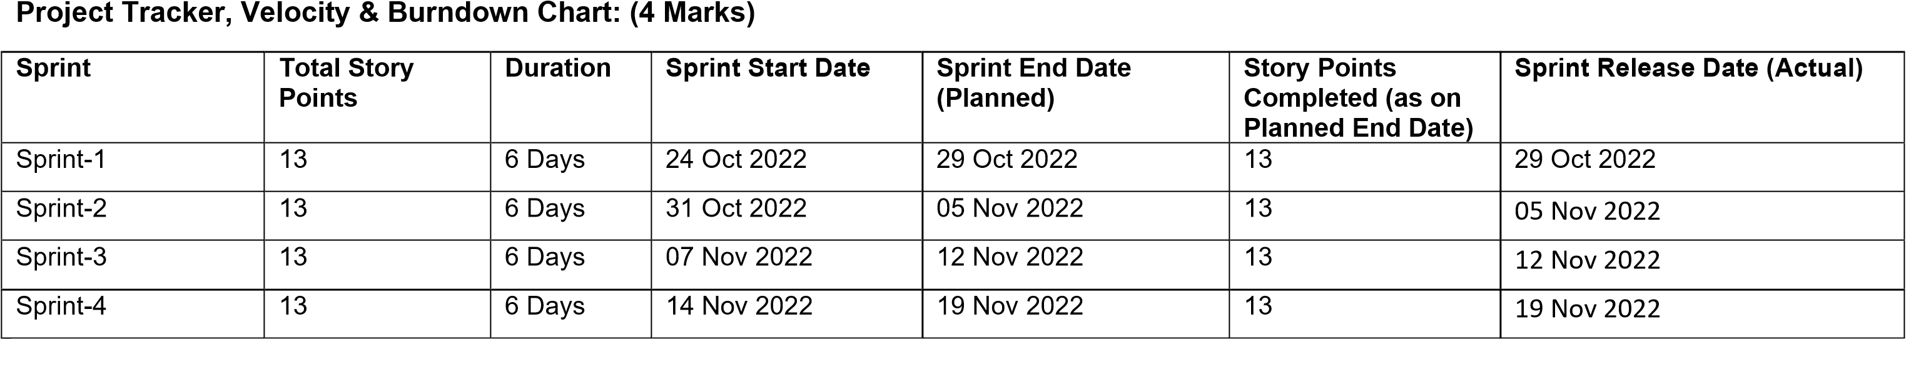

**Velocity:**

Imagine we have a 6-day sprint duration, and the velocity of the team is 13 (points per sprint). Let’s calculate the team’s average velocity (AV) per iteration unit (story points per day)

**AV = Sprint duration/Velocity = 13/6 = 2.16**

**Burndown Chart:**

A burn down chart is a graphical representation of work left to do versus time. It is often used in agile [software development](https://www.visual-paradigm.com/scrum/what-is-agile-software-development/) methodologies such as [Scrum.](https://www.visual-paradigm.com/scrum/scrum-in-3-minutes/) However, burn down charts can be applied to any project containing measurable progress over time.

